

Mobile Application Development

Lab 5



Muhammad daniyal Qureshi

021-18-0009

BSCS-VII

Contents

Activity 1: Create a Login Page using Menu 1

**Layout** 1

**Toolbar** 5

**Menu** 6

**Logic Code** 7

**Output** 10

Activity 2: Create floating context menu and Contextual Action Bar 13

**Layout** 13

**Menu** 14

**Logic Code** 15

**Output** 17

Activity 3: Menu Bar 20

**Layout** 20

**Menu** 20

**Logic Code** 20

**Output** 22

Activity 4: Context Menu 23

**Layout** 23

**Menu** 23

**Logic Code** 23

**Output** 25

# Activity 1: Create a Login Page using Menu

## **Layout**

<?xml version="1.0" encoding="utf-8"?>

<LinearLayout xmlns:android="http://schemas.android.com/apk/res/android"

    xmlns:app="http://schemas.android.com/apk/res-auto"

    xmlns:tools="http://schemas.android.com/tools"

    android:layout_width="match_parent"

    android:layout_height="match_parent"

    tools:context=".Home">

<include layout="@layout/toolbar"

    android:id="@+id/toolbar"

    />

</LinearLayout>

<?xml version="1.0" encoding="utf-8"?>

<LinearLayout xmlns:android="http://schemas.android.com/apk/res/android"

    xmlns:app="http://schemas.android.com/apk/res-auto"

    xmlns:tools="http://schemas.android.com/tools"

    android:layout_width="match_parent"

    android:layout_height="match_parent"

    android:background="#125312"

    android:orientation="vertical"

    tools:context=".MainActivity">

<include layout="@layout/toolbar"

    android:id="@+id/toolbar"

    />

    <EditText

        android:id="@+id/Email"

        android:layout_width="match_parent"

        android:layout_height="50dp"

        android:layout_gravity="center"

        android:layout_marginLeft="20dp"

        android:layout_marginTop="200dp"

        android:layout_marginRight="20dp"

        android:layout_weight="0"

        android:background="@color/white"

        android:hint="Email"

        android:textColor="@color/black"

        android:inputType="textEmailAddress" />

    <EditText

        android:id="@+id/password"

        android:layout_width="match_parent"

        android:layout_height="50dp"

        android:layout_gravity="center"

        android:layout_marginLeft="20dp"

        android:layout_marginTop="20dp"

        android:layout_marginRight="20dp"

        android:layout_weight="0"

        android:background="@color/white"

        android:hint="Password"

        android:inputType="textPassword"

        android:textColor="@color/black"

        />

    <Button

        android:id="@+id/button"

        android:layout_width="match_parent"

        android:layout_height="70dp"

        android:layout_gravity="center"

        android:layout_marginLeft="20dp"

        android:layout_marginTop="20dp"

        android:layout_marginRight="20dp"

        android:layout_weight="0"

        android:backgroundTint="@color/white"

        android:text="Login"

        android:textColor="#125312"

        android:onClick="login"

        />

    <TextView

        android:id="@+id/textView"

        android:layout_width="wrap_content"

        android:layout_height="wrap_content"

        android:layout_gravity="center"

        android:layout_marginTop="100dp"

        android:layout_weight="0"

        android:onClick="signup"

        android:text="Not a member ? Sign up now"

        android:textColor="@color/white"

        android:textSize="20sp" />

</LinearLayout>

<?xml version="1.0" encoding="utf-8"?>

<LinearLayout xmlns:android="http://schemas.android.com/apk/res/android"

    xmlns:app="http://schemas.android.com/apk/res-auto"

    xmlns:tools="http://schemas.android.com/tools"

    android:layout_width="match_parent"

    android:layout_height="match_parent"

    android:background="#1D2E1D"

    android:orientation="vertical"

    tools:context=".Signup">

    <EditText

        android:id="@+id/Name"

        android:layout_width="match_parent"

        android:layout_height="50dp"

        android:layout_gravity="center"

        android:layout_marginLeft="20dp"

        android:layout_marginTop="200dp"

        android:layout_marginRight="20dp"

        android:layout_weight="0"

        android:background="#808080"

        android:hint="Fullname"

        android:inputType="textPersonName" />

    <EditText

        android:id="@+id/Email"

        android:layout_width="match_parent"

        android:layout_height="50dp"

        android:layout_gravity="center"

        android:layout_marginLeft="20dp"

        android:layout_marginTop="20dp"

        android:layout_marginRight="20dp"

        android:layout_weight="0"

        android:background="#808080"

        android:hint="Email"

        android:inputType="textEmailAddress" />

    <EditText

        android:id="@+id/password"

        android:layout_width="match_parent"

        android:layout_height="50dp"

        android:layout_gravity="center"

        android:layout_marginLeft="20dp"

        android:layout_marginTop="20dp"

        android:layout_marginRight="20dp"

        android:layout_weight="0"

        android:background="#808080"

        android:hint="Password"

        android:inputType="textPassword"

        />

    <Button

        android:id="@+id/button"

        android:layout_width="match_parent"

        android:layout_height="70dp"

        android:layout_gravity="center"

        android:layout_marginLeft="20dp"

        android:layout_marginTop="20dp"

        android:layout_marginRight="20dp"

        android:layout_weight="0"

        android:backgroundTint="#FF1493"

        android:onClick="signup"

        android:text="Register"

        android:textColor="@color/white" />

    <TextView

        android:id="@+id/textView"

        android:layout_width="wrap_content"

        android:layout_height="wrap_content"

        android:layout_gravity="center"

        android:layout_marginTop="90dp"

        android:layout_weight="0"

        android:text="Already registered !Login Me."

        android:textColor="@color/white"

        android:textSize="20sp"

        android:onClick="login"

        />

</LinearLayout>

## **Toolbar**

<?xml version="1.0" encoding="utf-8"?>

<androidx.appcompat.widget.Toolbar xmlns:android="http://schemas.android.com/apk/res/android"

    android:layout_width="match_parent"

    android:layout_height="wrap_content"

    xmlns:app="http://schemas.android.com/apk/res-auto"

    android:background="@color/teal_700"

    android:id="@+id/toolbar"

    android:theme="@style/ThemeOverlay.AppCompat.Dark"

    app:logo="@drawable/abc_vector_test"

    app:titleTextColor="@color/white"

    >

</androidx.appcompat.widget.Toolbar>

## **Menu**

<?xml version="1.0" encoding="utf-8"?>

<menu xmlns:android="http://schemas.android.com/apk/res/android"

    xmlns:app="http://schemas.android.com/apk/res-auto"

    android:layout_width="match_parent"

    android:layout_height="wrap_content"

    app:logo="@drawable/facebook"

    android:theme="@style/ThemeOverlay.AppCompat.Dark"

    >

    <item

    android:title="HOME"

    android:id="@+id/home"

    app:showAsAction="always"

    >

</item>

    <item

        android:title="|"

        android:id="@+id/divider"

        app:showAsAction="always"

        >

    </item>

    <item

        android:title="LOGOUT"

        android:id="@+id/logout"

        app:showAsAction="always"

        >

    </item>

</menu>

## **Logic Code**

package com.example.login;

import androidx.annotation.NonNull;

import androidx.appcompat.app.AppCompatActivity;

import androidx.appcompat.widget.Toolbar;

import android.content.Intent;

import android.os.Bundle;

import android.view.Menu;

import android.view.MenuInflater;

import android.view.MenuItem;

public class Home extends AppCompatActivity {

    @Override

    protected void onCreate(Bundle savedInstanceState) {

        super.onCreate(savedInstanceState);

        setContentView(R.layout.activity_home);

        Toolbar toolbar=findViewById(R.id.toolbar);

        setSupportActionBar(toolbar);

    }

    @Override

    public boolean onCreateOptionsMenu(Menu menu) {

        MenuInflater inflater=getMenuInflater();

        inflater.inflate(R.menu.menu,menu);

        return true;

    }

    @Override

    public boolean onOptionsItemSelected(@NonNull MenuItem item) {

        switch (item.getItemId()){

            case R.id.logout:

            Intent intent=new Intent(this,MainActivity.class);

            startActivity(intent);

                break;

        }

        return super.onOptionsItemSelected(item);

    }

}

package com.example.login;

import androidx.annotation.Nullable;

import androidx.appcompat.app.AppCompatActivity;

import androidx.appcompat.widget.Toolbar;

import android.content.Intent;

import android.content.SharedPreferences;

import android.os.Bundle;

import android.util.Log;

import android.view.Menu;

import android.view.MenuInflater;

import android.view.View;

import android.widget.EditText;

import android.widget.Toast;

import java.util.zip.Inflater;

public class MainActivity extends AppCompatActivity {

    @Override

    protected void onCreate(Bundle savedInstanceState) {

        super.onCreate(savedInstanceState);

        setContentView(R.layout.activity_main);

    }

    public void login(View view){

        EditText Email=(EditText)findViewById(R.id.Email);

        EditText Password=(EditText)findViewById(R.id.password);

        SharedPreferences prefs=getSharedPreferences("user",MODE_PRIVATE);

        String d=prefs.getString(Email.getText().toString(),"none");

        Log.i("val",d);

        if(d.equals(Password.getText().toString()))

            Toast.makeText(this,"Login Successfully",Toast.LENGTH_LONG).show();

        else

            Toast.makeText(this, "Sign up first", Toast.LENGTH_LONG).show();

        Intent intent=new Intent(this,Home.class);

        startActivity(intent);

    }

    public void signup(View view){

    Intent intent=new Intent(this,Signup.class);

    startActivity(intent);

    }

}

package com.example.login;

import androidx.appcompat.app.AppCompatActivity;

import android.content.Intent;

import android.content.SharedPreferences;

import android.os.Bundle;

import android.view.View;

import android.widget.EditText;

import android.widget.Toast;

public class Signup extends AppCompatActivity {

    @Override

    protected void onCreate(Bundle savedInstanceState) {

        super.onCreate(savedInstanceState);

        setContentView(R.layout.activity_signup);

    }

    public void signup(View view){

        EditText Email=(EditText)findViewById(R.id.Email);

        EditText Password=(EditText)findViewById(R.id.password);

        SharedPreferences prefs=getSharedPreferences("user",MODE_PRIVATE);

        SharedPreferences.Editor editor=prefs.edit();

        editor.putString(Email.getText().toString(),Password.getText().toString());

        editor.commit();

        Toast.makeText(this,"You are registered",Toast.LENGTH_LONG).show();

    }

    public void login(View view){

    Intent intent=new Intent(this,MainActivity.class);

    startActivity(intent);

    }

}

## **Output**

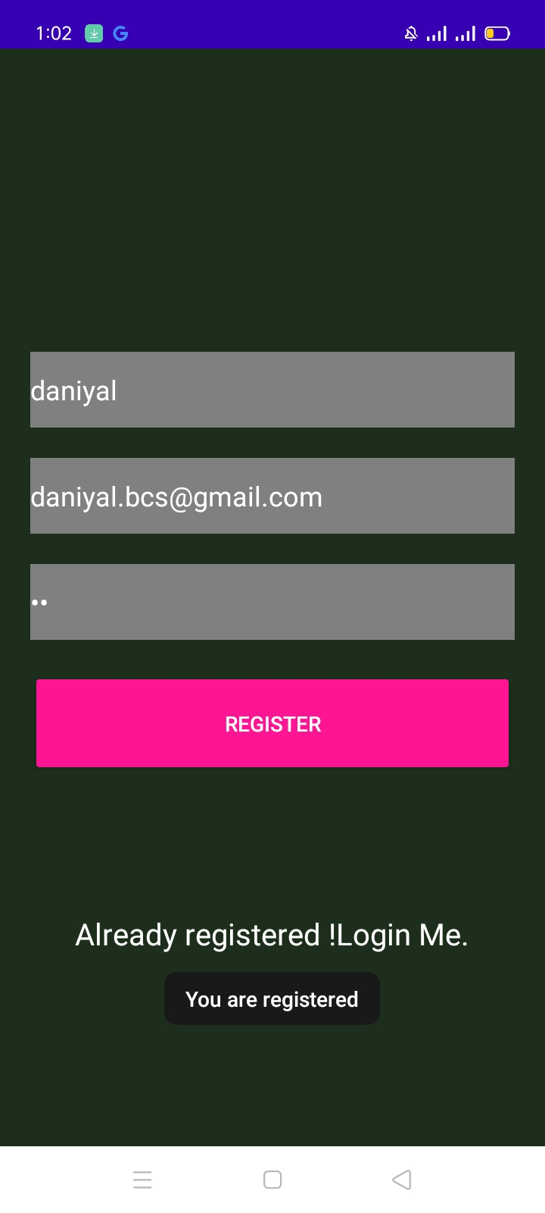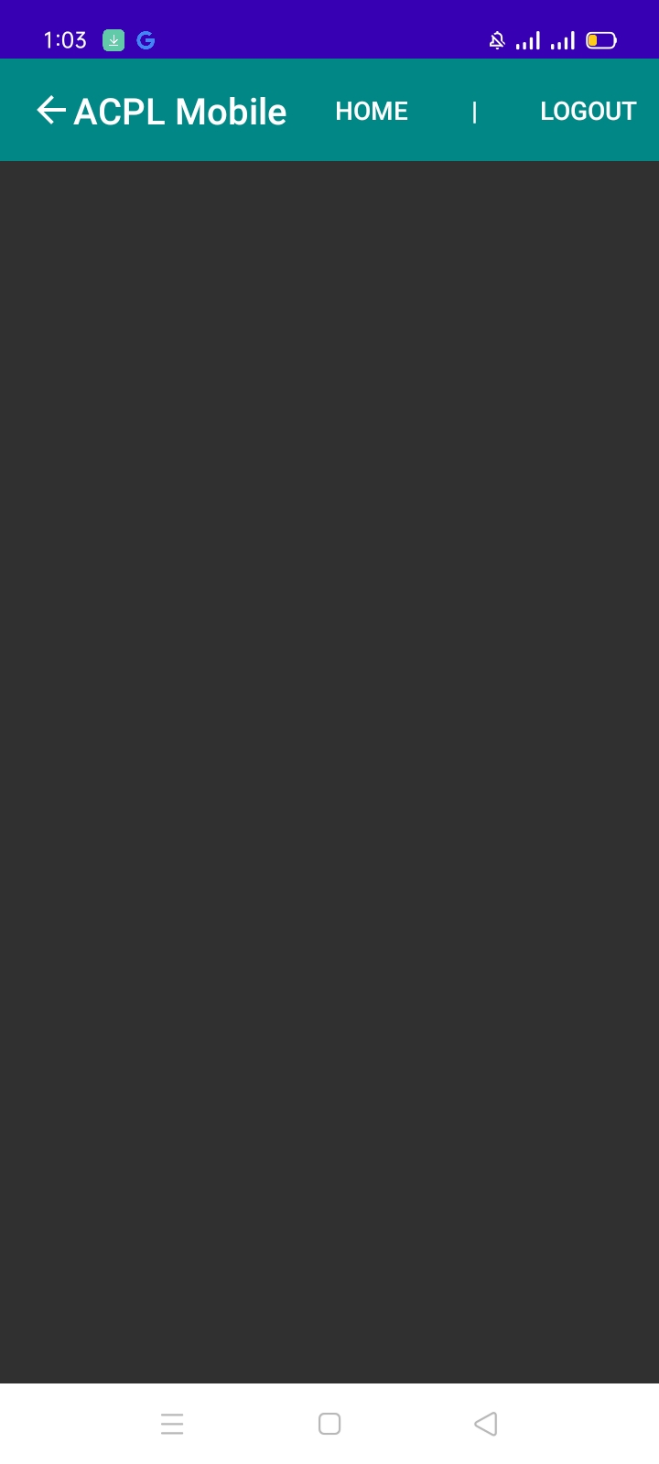

# Activity 2: Create floating context menu and Contextual Action Bar

## **Layout**

<?xml version="1.0" encoding="utf-8"?>

<LinearLayout xmlns:android="http://schemas.android.com/apk/res/android"

    xmlns:app="http://schemas.android.com/apk/res-auto"

    xmlns:tools="http://schemas.android.com/tools"

    android:layout_width="match_parent"

    android:layout_height="match_parent"

    tools:context=".MainActivity">

    <ImageView

        android:id="@+id/imageView"

        android:layout_width="wrap_content"

        android:layout_height="wrap_content"

        android:layout_weight="1"

        app:srcCompat="@drawable/img" />

    <Button

        android:id="@+id/button2"

        android:layout_width="wrap_content"

        android:layout_height="wrap_content"

        android:layout_weight="1"

        android:onClick="next"

        android:text="next" />

</LinearLayout>

<?xml version="1.0" encoding="utf-8"?>

<androidx.constraintlayout.widget.ConstraintLayout xmlns:android="http://schemas.android.com/apk/res/android"

    xmlns:app="http://schemas.android.com/apk/res-auto"

    xmlns:tools="http://schemas.android.com/tools"

    android:layout_width="match_parent"

    android:layout_height="match_parent"

    tools:context=".MainActivity2">

    <Button

        android:id="@+id/button"

        android:layout_width="wrap_content"

        android:layout_height="wrap_content"

        android:layout_marginStart="44dp"

        android:layout_marginLeft="44dp"

        android:layout_marginTop="140dp"

        android:background="#5A1D1D"

        android:maxLines="8"

        android:text="Shakespeare \n\n\n\n\n\nHamlet"

        app:backgroundTint="#808080"

        app:layout_constraintStart_toStartOf="parent"

        app:layout_constraintTop_toTopOf="parent" />

</androidx.constraintlayout.widget.ConstraintLayout>

## **Menu**

<?xml version="1.0" encoding="utf-8"?>

<menu xmlns:android="http://schemas.android.com/apk/res/android">

    <item android:title="Download image"></item>

    <item android:title="Open image in new tab"></item>

    <item android:title="Search Google for this image"></item>

    <item android:title="Share image"></item>

</menu>

<?xml version="1.0" encoding="utf-8"?>

<menu xmlns:android="http://schemas.android.com/apk/res/android"

    xmlns:app="http://schemas.android.com/apk/res-auto"

    >

<item android:title="label"

    android:icon="@drawable/label"

    app:showAsAction="always"

    >

</item>

    <item android:title="color"

        android:icon="@drawable/color"

        app:showAsAction="always"

        >  </item>

    <item android:title="pin"

        android:icon="@drawable/pin"

        app:showAsAction="always"

        >

    </item>

    <item android:title="click"

        android:icon="@drawable/click"

        app:showAsAction="always"

        >

    </item>

</menu>

## **Logic Code**

package com.example.float_menu;

import androidx.annotation.NonNull;

import androidx.appcompat.app.AppCompatActivity;

import android.content.Intent;

import android.os.Bundle;

import android.view.ContextMenu;

import android.view.MenuInflater;

import android.view.MenuItem;

import android.view.View;

import android.widget.Adapter;

import android.widget.AdapterView;

public class MainActivity extends AppCompatActivity {

    @Override

    protected void onCreate(Bundle savedInstanceState) {

        super.onCreate(savedInstanceState);

        setContentView(R.layout.activity_main);

        registerForContextMenu(findViewById(R.id.imageView));

    }

    @Override

    public void onCreateContextMenu(ContextMenu menu, View v, ContextMenu.ContextMenuInfo menuInfo) {

        super.onCreateContextMenu(menu, v, menuInfo);

        MenuInflater inflater=getMenuInflater();

        inflater.inflate(R.menu.menu,menu);

    }

    public void next(View view){

        Intent intent=new Intent(this,MainActivity2.class);

        startActivity(intent);

    }

}

package com.example.float_menu;

import androidx.appcompat.app.AppCompatActivity;

import android.app.Application;

import android.content.Context;

import android.os.Bundle;

import android.view.ActionMode;

import android.view.Menu;

import android.view.MenuInflater;

import android.view.MenuItem;

import android.view.View;

import android.widget.TextView;

import android.widget.Toast;

public class MainActivity2 extends AppCompatActivity {

    ActionMode actionMode;

    @Override

    protected void onCreate(Bundle savedInstanceState) {

        super.onCreate(savedInstanceState);

        setContentView(R.layout.activity_main2);

        TextView txt=findViewById(R.id.button);

        txt.setOnLongClickListener(new View.OnLongClickListener() {

            @Override

            public boolean onLongClick(View v) {

                if(actionMode!=null)

                return false;

                actionMode=startActionMode(actionModeCallback);

                txt.setSelected(true);

                return  true;

            }

        });

    }

    private ActionMode.Callback actionModeCallback=new ActionMode.Callback() {

        @Override

        public boolean onCreateActionMode(ActionMode mode, Menu menu) {

            MenuInflater inflater=mode.getMenuInflater();

            inflater.inflate(R.menu.menu2,menu);

            return true;

        }

        @Override

        public boolean onPrepareActionMode(ActionMode mode, Menu menu) {

            return false;

        }

        @Override

        public boolean onActionItemClicked(ActionMode mode, MenuItem item) {

            return false;

        }

        @Override

        public void onDestroyActionMode(ActionMode mode) {

        actionMode=null;

        }

    };

}

## **Output**

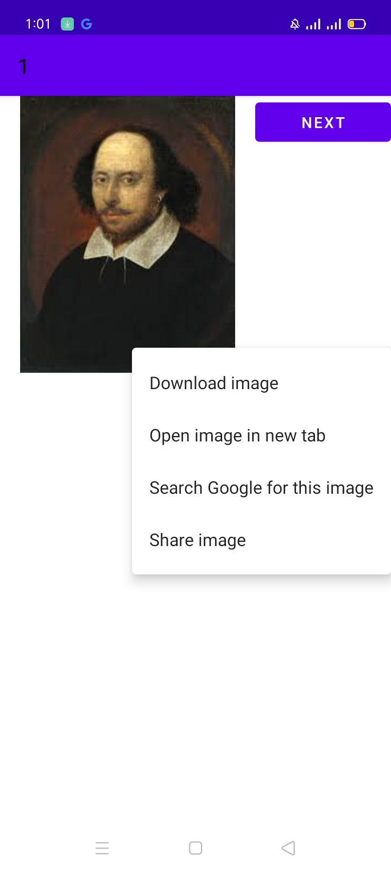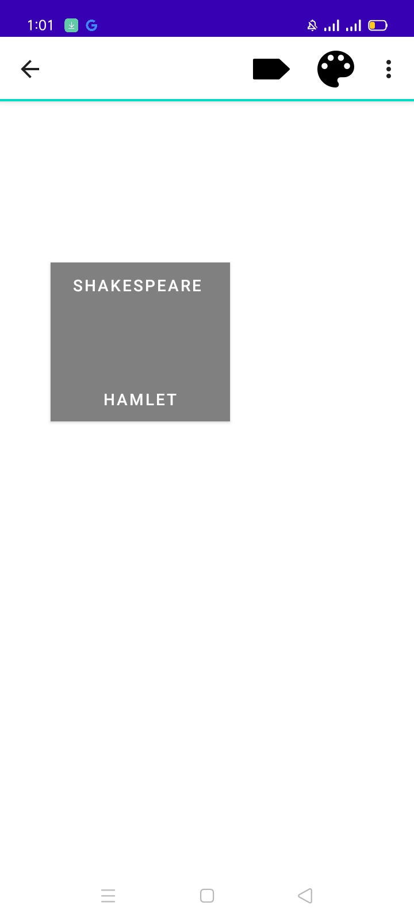

# Activity 3: Menu Bar

## **Layout**

<?xml version="1.0" encoding="utf-8"?>

<androidx.constraintlayout.widget.ConstraintLayout xmlns:android="http://schemas.android.com/apk/res/android"

    xmlns:app="http://schemas.android.com/apk/res-auto"

    xmlns:tools="http://schemas.android.com/tools"

    android:layout_width="match_parent"

    android:layout_height="match_parent"

    tools:context=".MainActivity"/>

## **Menu**

<?xml version="1.0" encoding="utf-8"?>

<menu xmlns:android="http://schemas.android.com/apk/res/android">

<item android:title="Search"></item>

    <item android:title="Upload"></item>

    <item android:title="Copy"></item>

    <item android:title="Print"></item>

    <item android:title="Share"></item>

    <item android:title="Bookmark"></item>

</menu>

## **Logic Code**

package com.example.sample_menu;

import androidx.annotation.NonNull;

import androidx.appcompat.app.AppCompatActivity;

import android.os.Bundle;

import android.view.Menu;

import android.view.MenuInflater;

public class MainActivity extends AppCompatActivity {

    @Override

    protected void onCreate(Bundle savedInstanceState) {

        super.onCreate(savedInstanceState);

        setContentView(R.layout.activity_main);

    }

    @Override

    public boolean onCreateOptionsMenu(Menu menu) {

        MenuInflater inflater=getMenuInflater();

        inflater.inflate(R.menu.menu,menu);

        return true;

    }

}

## **Output**

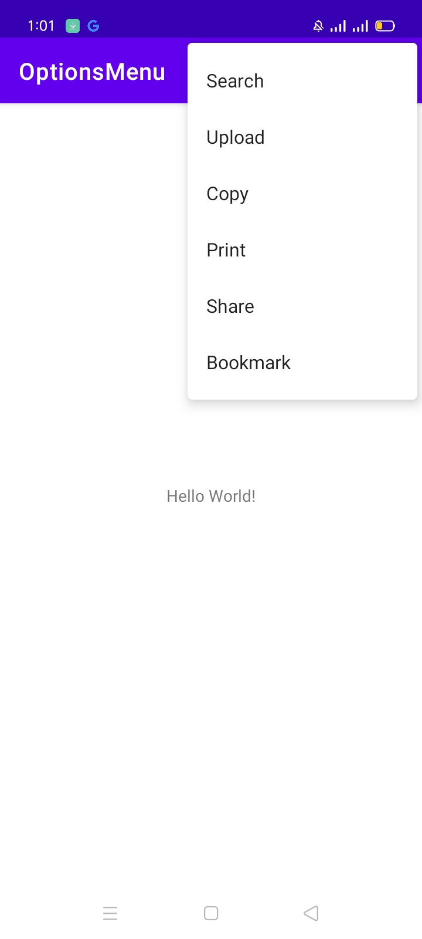

# Activity 4: Context Menu

## **Layout**

<?xml version="1.0" encoding="utf-8"?>

<LinearLayout xmlns:android="http://schemas.android.com/apk/res/android"

    xmlns:app="http://schemas.android.com/apk/res-auto"

    xmlns:tools="http://schemas.android.com/tools"

    android:layout_width="match_parent"

    android:layout_height="match_parent"

    android:orientation="vertical"

    tools:context=".MainActivity">

    <Button

        android:id="@+id/button2"

        android:layout_width="wrap_content"

        android:layout_height="wrap_content"

        android:layout_gravity="center"

        android:layout_weight="0"

        android:text="LONG PRESS ME" />

</LinearLayout>

## **Menu**

<?xml version="1.0" encoding="utf-8"?>

<menu xmlns:android="http://schemas.android.com/apk/res/android">

    <item android:title="Upload "></item>

    <item android:title="Search"></item>

    <item android:title="Share"></item>

    <item android:title="Bookmark"></item>

</menu>

## **Logic Code**

package com.example.float_menu;

import androidx.annotation.NonNull;

import androidx.appcompat.app.AppCompatActivity;

import android.content.Intent;

import android.os.Bundle;

import android.view.ContextMenu;

import android.view.MenuInflater;

import android.view.MenuItem;

import android.view.View;

import android.widget.Adapter;

import android.widget.AdapterView;

public class MainActivity extends AppCompatActivity {

    @Override

    protected void onCreate(Bundle savedInstanceState) {

        super.onCreate(savedInstanceState);

        setContentView(R.layout.activity_main);

        registerForContextMenu(findViewById(R.id.button2));

    }

    @Override

    public void onCreateContextMenu(ContextMenu menu, View v, ContextMenu.ContextMenuInfo menuInfo) {

        super.onCreateContextMenu(menu, v, menuInfo);

        MenuInflater inflater=getMenuInflater();

        inflater.inflate(R.menu.menu,menu);

    }

    public void next(View view){

        Intent intent=new Intent(this,MainActivity2.class);

        startActivity(intent);

    }

}

## **Output**

